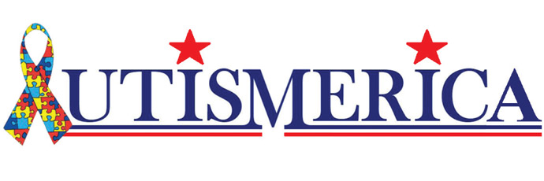
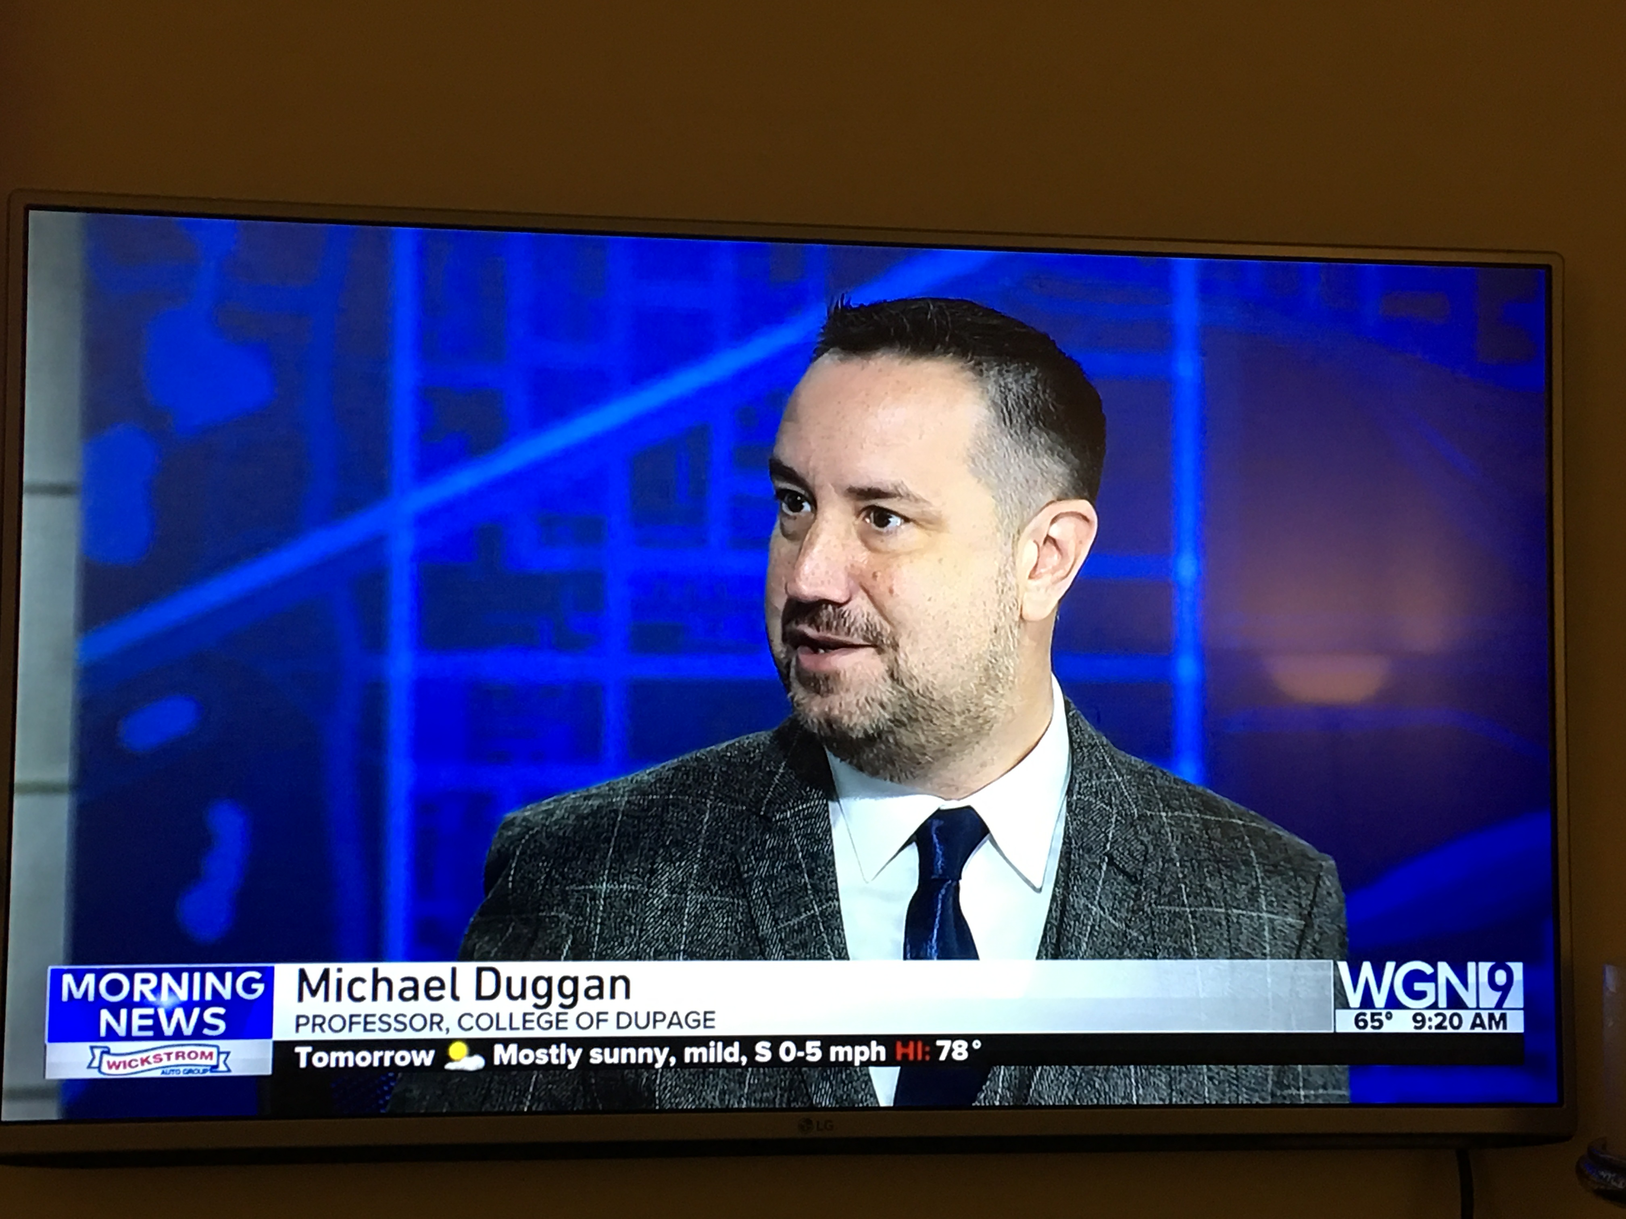
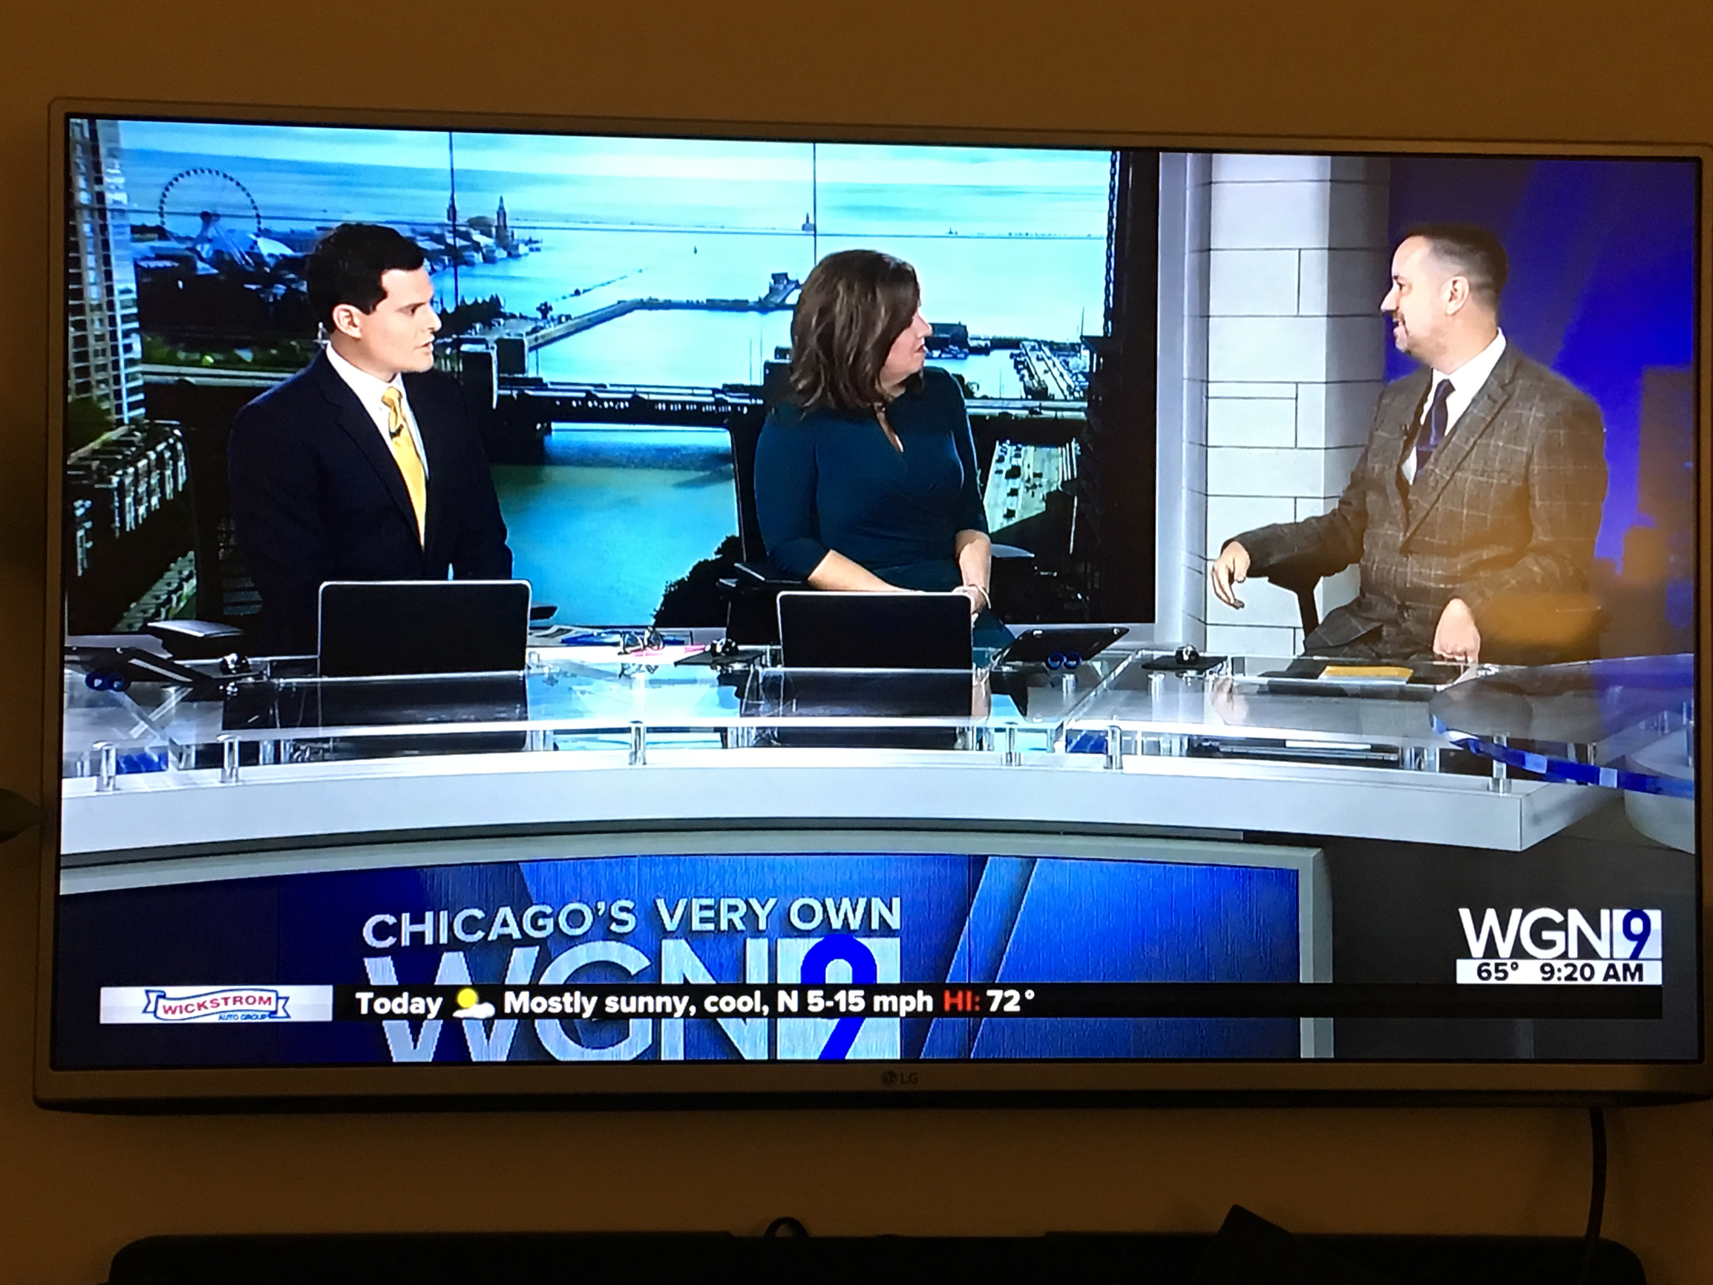

Dr. Michael Duggan
  - Local Author, Practicing Therapist for over 20 years
Dr. Michael Duggan, Licensed Clinical Professional Counselor (LCPC) and Certified Rehabilitation Counselor (CRC) is a Professor and a Counselor for Students with Disabilities at College of DuPage (COD), where he is well known for his expertise and his passion for empowering students with disabilities. In his twelve years at COD he has helped establish the Vocational Skills Program, a program for students with developmental disabilities, and Autismerica, a social/support group for students on the autism spectrum. He has also been awarded COD’s Outstanding Divisional Faculty of the Year, Outstanding Academic Advisor of the Year (twice), and Outstanding Club Advisor of the Year for his work on Autismerica.  Before coming to COD, he directed the second largest college Disability Services program in Oregon at Chemeketa Community College and was elected as President of the Oregon Association of Higher Education and Disability (ORAHEAD), advocating for equality and improved services for college students with disabilities. His first published book is titled, “First Class Support for College Students on the Autism Spectrum: Practical Advice for College Counselors and Educators”, by Jessica Kingsley Publishing. |  | First Class Support for College Students on the Autism Spectrum (2017)—Available now on Amazon and wherever books are sold!

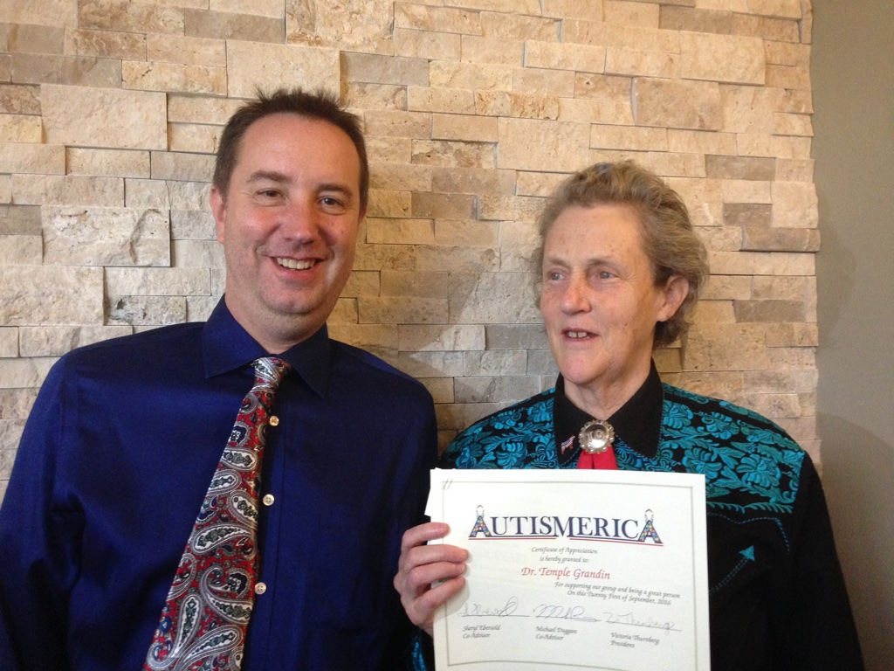 |  | “Reviews of ‘First Class Support…’”  “This book, which addresses college advisors and counselors, faculty, and parents, is the key to united a team of support for any college student with autism. Dr. Duggan has given us an accessible, upbeat, and realistic guide, with clear advice for a wide range of challenging situations.—  Dr. Karin Evans, Professor of English, College of DuPage
Reviews Continued…  “Dr. Michael Duggan has been a dedicated and effective advocate for students on the autism spectrum and their families for over 20 years. He has created the ultimate guide to show how to assist these students with a passionate, step-by-step companion for college counselors, families, and aspiring college students.”  Dr. Maria Rago, Clinical Psychologist |  | 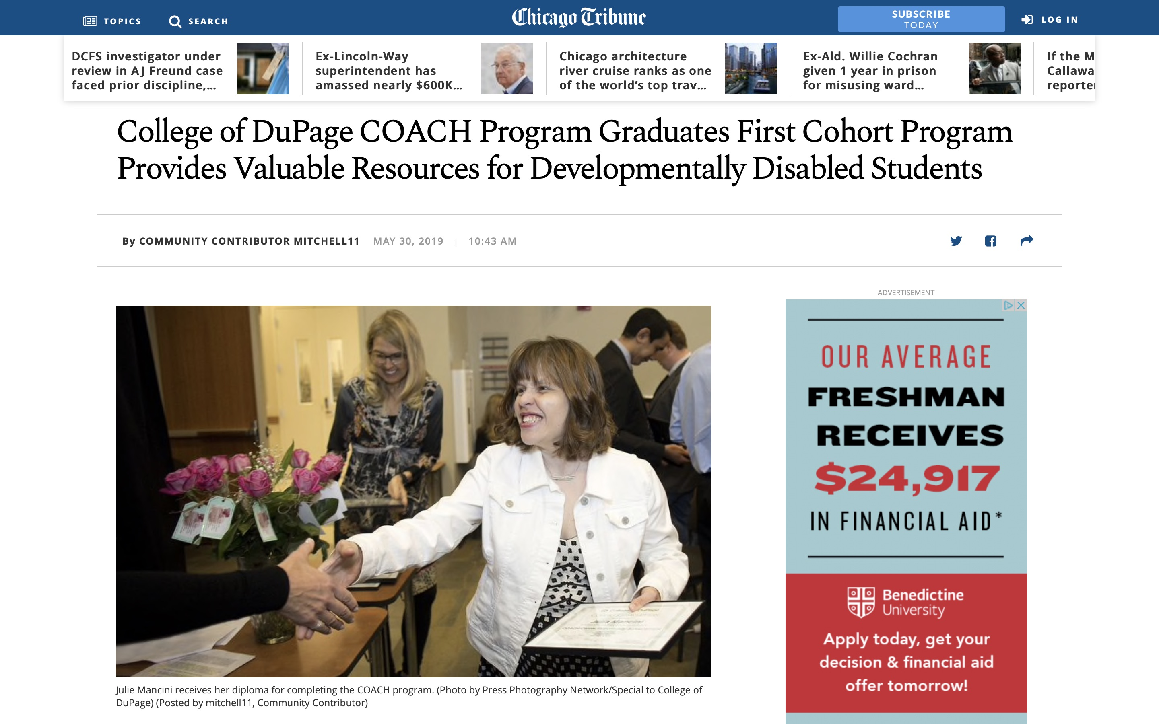
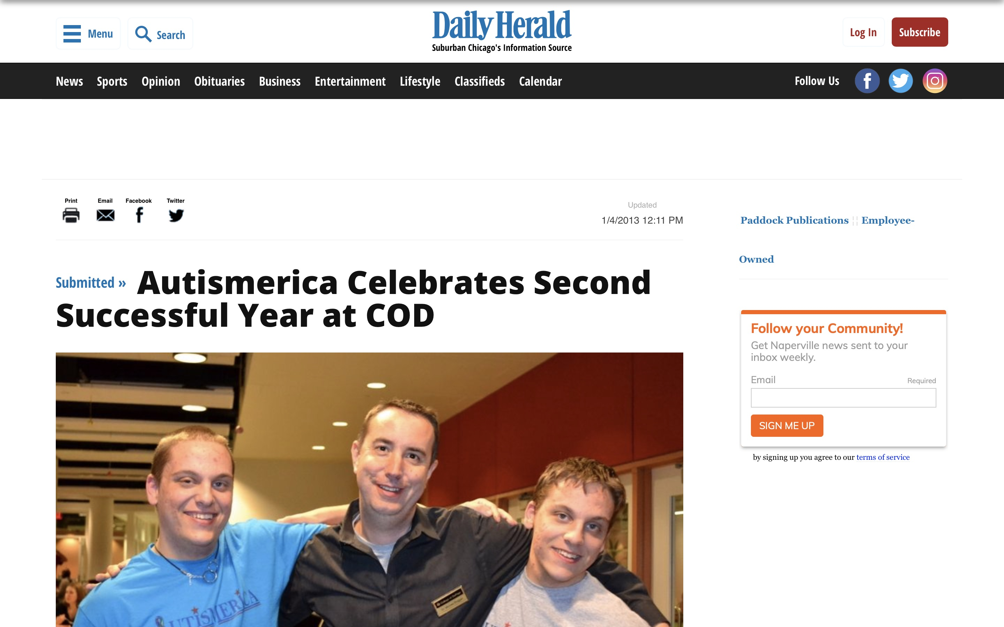 |  | Parents Reviews…  As a parent preparing to send my son who is autistic to college, this was a great read full of fabulous tips for success in both college and life. Highly recommended!!”.  Parental Review Mo P on Amazon.com

For More Information…
Visit Dr. Duggan’s website at michaelwduggan.com or email him at michaelwduggan@yahoo.com

